**CITY OF PITTSBURGH**

**Department of Public Safety**



911 Service Calls Data Analysis

* By Aditya Nayak

(Prospective Crime Analyst)

To, Larry Scirotto;

Chief of Police; Pittsburgh, PA

October 4, 2024

**Summary**

**Overview: -**

The assigned dataset consists of 911 call records of a total of 39,556 instances of which 38,779 (98%) being unique, recorded between June 2024 to August 2024, all initiated by residents in Pittsburgh. In this time frame, majority of calls made were majorly comprising of Welfare checks, Neighborhood or domestic disputes/disruptions, parking/ vehicle violations etc. out of which:

* ***11,442 (28.9%)*** of calls made led to filing a report.
* ***44 (0.1%)*** of calls led to issue warning citations, ***2,040 (5.2%)*** involving police of call & ***198 (0.5%)*** lead to an arrest.
* ***18,011 (45.6%)*** calls were either cancelled (671), disregarded (1,486) or did not require a report to be filed (15,854).
* ***1,263 (3.2%)*** calls were false alarms.

The emergency calls made were mainly in regards to welfare checks, burglary alarm tipoffs, neighbor disruptions, parking / vehicle violations etc. as per CAD EOC manual codes. Majority number of calls made in regards to public safety can be seen in the chart as follows:

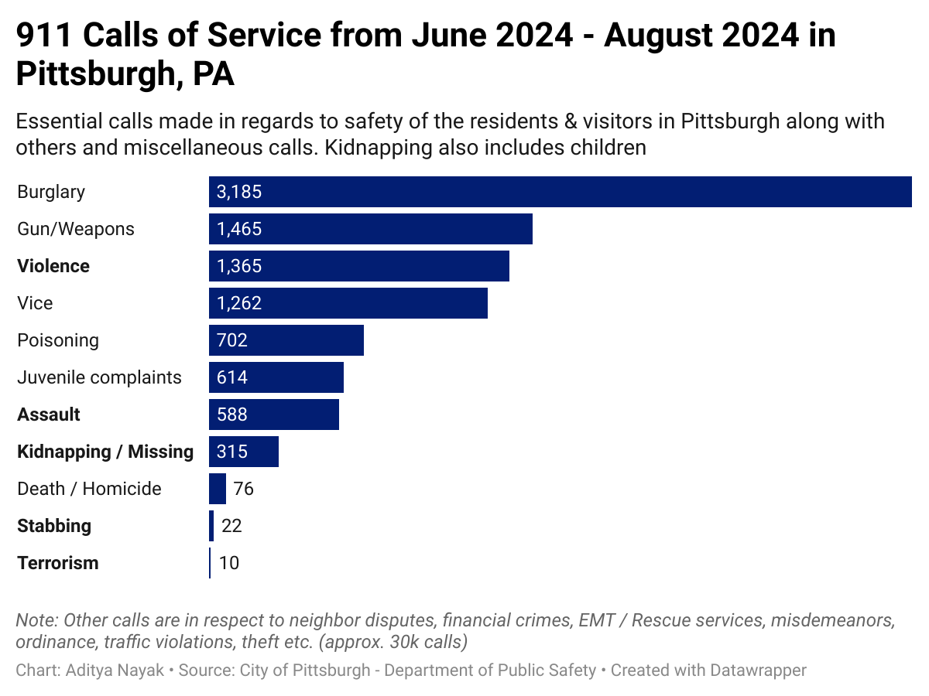

The majority of calls made had P2 priority level assigned, where P0 being classified as the highest and P5 as the lowest. The response time taken to reach to the location of the call varied from minutes to hours with a **minimum time** taking ***under a minute*** and **maximum** of ***3 hours 40 minutes***. However, there were instances where the time was not recorded accurately or was missing, due to which the time could not be accurately determined.

Locations of calls can be seen from the map below:

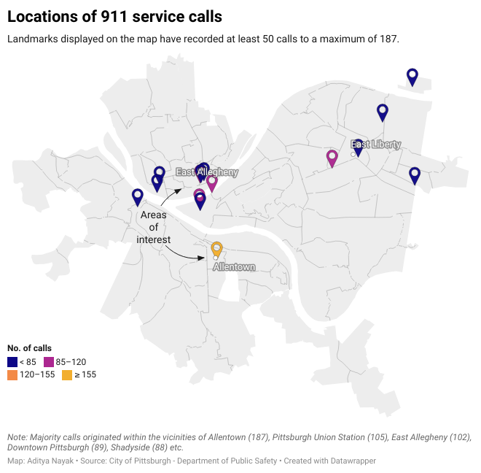

**Monthly Insights: -**

1. **June 1 – June 30 2024:**

June consisted of 12,751 unique calls out of a total 13,003 mainly in regards to neighbor disputes, vehicular concerns, ordinance etc.

During this period, calls were essentially made during **daylight** hours especially between 12:00 – 16:00 hours and having a total of **3,658 reports** filed out of which *472* were *Theft* related, *180* were *Violence* reports (Fights, Criminal Mischief etc.), *169* were of *Burglary*, *108* related to *Guns / Firearms*, *103* were of *Assault*, *38* reports related to *Kidnapping*, *5* *Stabbing* reports and 1 in regards to a *Terrorist activity (Bomb Threat)* while the rest of the reports were either non-threatening to the public or miscellaneous reports.

And the month saw a total ***65 arrests*** of which *31 arrests* were **miscellaneous**, *9* **Gun-related**, *7* **Ordinance** based, *2* **Burglary** & *1* based on **Kidnapping**.

1. **July 1 – July 31 2024:**

July saw a total of 13,093 unique calls being made out a total of 13,352 with similar number of calls made in regards to municipal cases, traffic / parking violations, ordinance complaints etc.

This time however, the calls were made during **after-hours** in the evening (PM) between 16:00 – 20:00 hours. However, there was an 8% rise (3,989) in the number of reports filed by the department (+331 reports) compared to June having *509* were *Theft* related, *235* *Violence* reports (Fights, PFA Violations, Criminal Mischief etc.), *185* *Burglary incidents*, *110* related to *Guns / Firearms*, *87* *Assault reports*, *48* reports related to *Kidnapping*, 22 *Death / Homicide reports* *5* *Stabbing* reports and *5* in regards to *Terrorist activities (3 Bomb Threats; 2 Hostage scenarios)*.

There were also *64 arrests* made in July where *40 arrests* were made in reference to ordinance, misdemeanors & neighbor complaints; *6* **Gun-related**, *2* in **Burglary** and in **Assault** and *1* based on a **Stabbing** report.

1. **August 1 – August 31 2024**

There were 12,935 unique calls made out of a total of 13,201 with calls made in misdemeanor complaints, municipal violations, traffic / parking violations, ordinance complaints etc.

This time as well, the calls were made during **after-hours** in the evening (PM) between 16:00 – 20:00 hours. However, there was a 5% decrease (3,795) in the number of reports compared to July (- 194 reports) and a 3% increase compared to June filed by the department (+137 reports) having *543* *Theft* related, *182* *Violence* reports (Fights, PFA Violations, Foot pursuits etc.), *157* *Burglary incidents*, *120* related to *Guns / Firearms*, *116* *Assault cases*, *51* reports related to *Kidnapping / AMBER alerts*, *5* *Stabbing* reports and *5* in regards to *Terrorist activities (3 Bomb Threats; 2 Hostage scenarios)*.

August however saw a total of *69 arrests* made which was the highest total among the 3 months but the arrests made were for predominantly made for non-major crimes such as **Misdemeanor arrests** (9), **Neighbor disputes** (22), **Theft** (6), *5* **Gun-related**, *4* in **Burglary**,3 in **Assault** & 1 arrest in a **Kidnapping** case.

**Conclusion**

With a total of 11,442 reports being filed in a 3-month period in vehicle leading to 198 arrests in relation to neighbor / family disputes, misdemeanor charges, ordinance etc. The following

1. Dispatch patrol officers during evening & night shifts to be on lookout incidents of Burglary / Theft as 2,028 reports were filed and 16 arrests were made during daylight.
2. Conduct community engagement workshops & promote conflict de-escalation strategies within communities.
3. Research on methods to inculcate additional technologies (e.g. AI, robot etc.) and identify cases in which data quality and availability, technology maturity, and ethical constraints serve both the needs of the department & the community to improve performance efficiency of department operations.

For detailed insights on specific crime categories, click [here](https://public.tableau.com/views/CrimeAnalystassesmentPittsburgh/Story1?:language=en-US&:sid=&:redirect=auth&:display_count=n&:origin=viz_share_link).

**End of Memo**